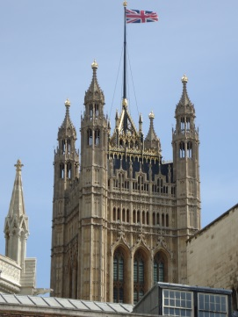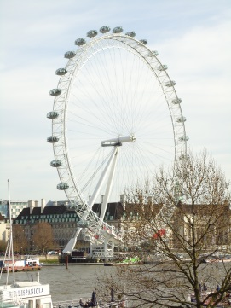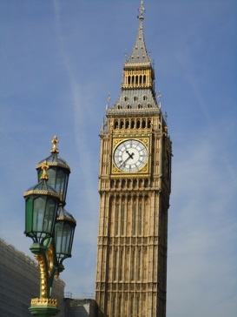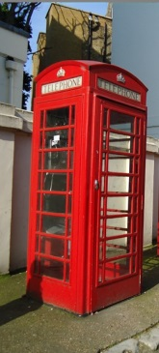

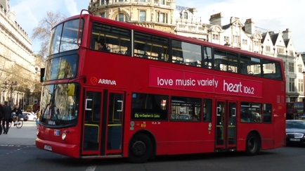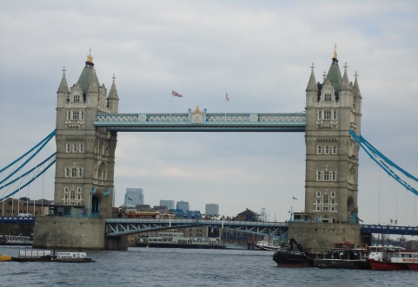

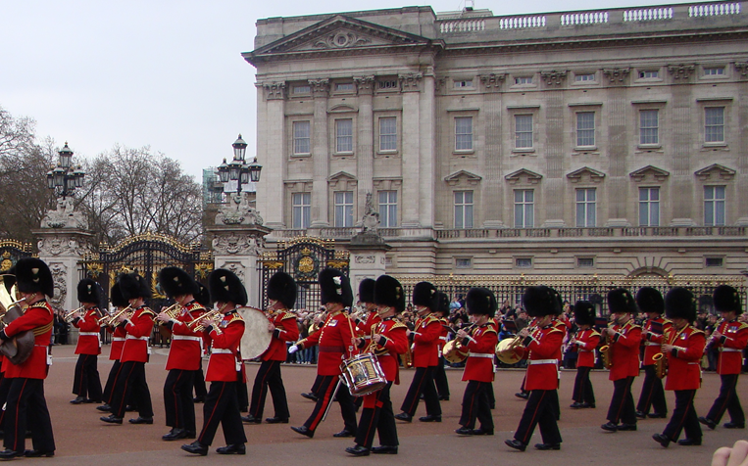

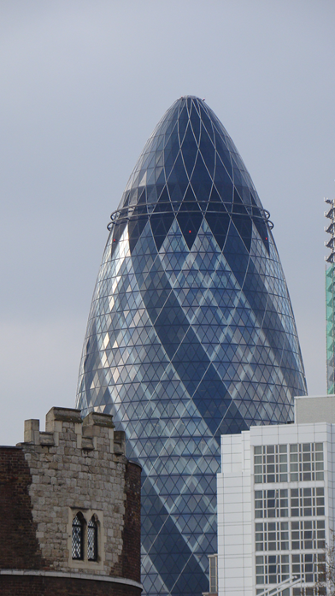 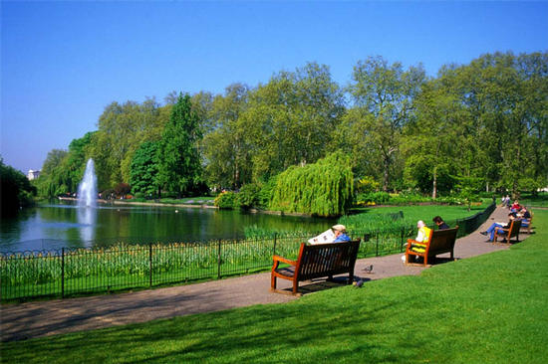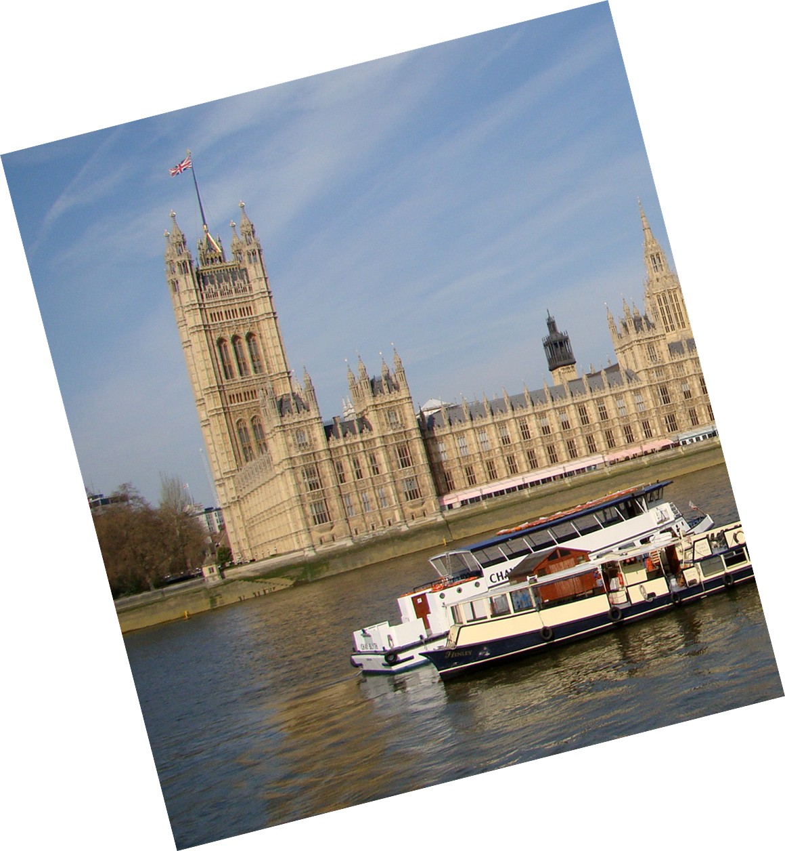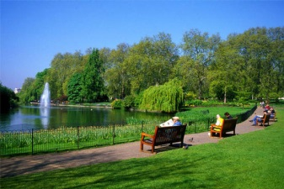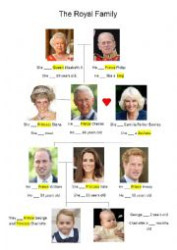 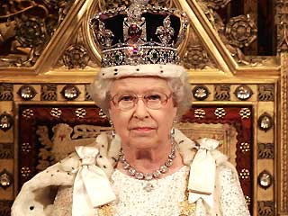

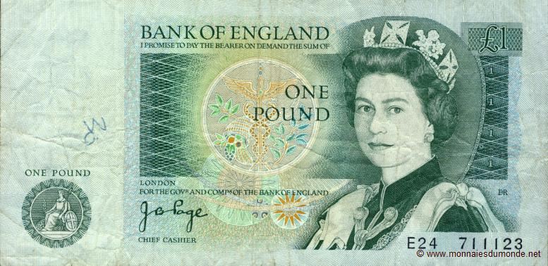

**Annexe 5 : bande numérotée des monuments ( jeu « let’s visit London ! » niveau 1**

|  |  |  |  |  |  |  |  |  |  |  |  |
| --- | --- | --- | --- | --- | --- | --- | --- | --- | --- | --- | --- |
| **1** | **2** | | **3** | | **4** | | | **5** | | **6** | |
|  |  | |  | |  | | |  | |  | |
| **1** | | **2** | | **3** | | **4** | **5** | | **6** | |
|  | |  | |  | |  |  | |  | |
| **1** | | **2** | | **3** | | **4** | **5** | | **6** | |
|  | |  | |  | |  |  | |  | |
| **1** | | **2** | | **3** | | **4** | **5** | | **6** | |
|  | |  | |  | |  |  | |  | |
| **1** | | **2** | | **3** | | **4** | **5** | | **6** | |
|  | |  | |  | |  |  | |  | |
| **1** | | **2** | | **3** | | **4** | **5** | | **6** | |
|  | |  | |  | |  |  | |  | |

**Annexe 6 : bande numérotée des monuments ( jeu « let’s visit London ! » niveau 2**

|  |  |  |  |  |  |  |  |  |  |  |  |
| --- | --- | --- | --- | --- | --- | --- | --- | --- | --- | --- | --- |
| **1** | **2** | | **3** | | **4** | | **5** | | | **6** | |
|  | C:\Users\sylvie favre\Desktop\projet 20015 2016\activités\episode 1\images londres\Image1.png | |  | |  | |  | | | C:\Users\sylvie favre\Desktop\anim lve culture\parc.jpg | |
| **1** | | **2** | | **3** | | **4** | | **5** | **6** | |
|  | | C:\Users\sylvie favre\Desktop\projet 20015 2016\activités\episode 1\images londres\Image2.png | |  | | C:\Users\sylvie favre\Desktop\projet 20015 2016\activités\episode 1\images londres\Image1.png | |  |  | |
| **1** | | **2** | | **3** | | **4** | | **5** | **6** | |
|  | |  | | C:\Users\sylvie favre\Desktop\anim lve culture\parc.jpg | |  | |  |  | |
| **1** | | **2** | | **3** | | **4** | | **5** | **6** | |
|  | |  | |  | |  | |  | C:\Users\sylvie favre\Desktop\projet 20015 2016\activités\episode 1\images londres\Image1.png | |
| **1** | | **2** | | **3** | | **4** | | **5** | **6** | |
|  | |  | |  | |  | |  | C:\Users\sylvie favre\Desktop\projet 20015 2016\activités\episode 1\images londres\Image2.png | |
| **1** | | **2** | | **3** | | **4** | | **5** | **6** | |
|  | | C:\Users\sylvie favre\Desktop\projet 20015 2016\activités\episode 1\images londres\Image10 (2).jpg | |  | | C:\Users\sylvie favre\Desktop\projet 20015 2016\activités\episode 1\images londres\Image2.png | |  |  | |