Kookaburra

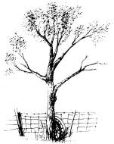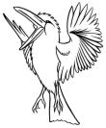
Kookaburra sits in the old gum tree,
Merry, Merry king of the bush is he,
Laugh kookaburra, Laugh
kookaburra, gay your life must be.

Kookaburra

Kookaburra sits in the old gum tree,
Merry, Merry king of the bush is he,
Laugh kookaburra, Laugh
kookaburra, gay your life must be.

